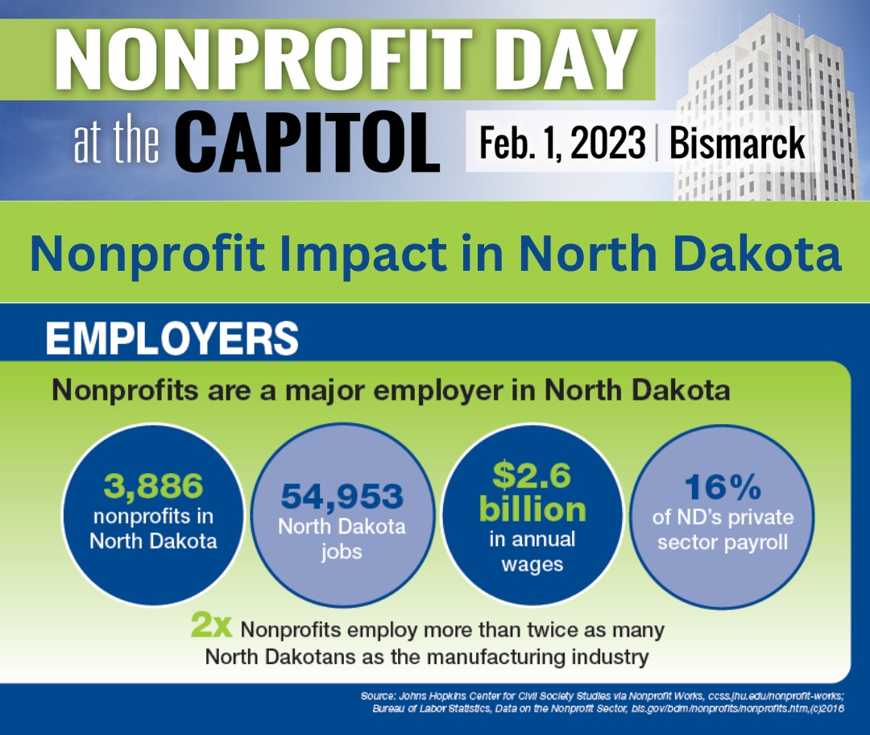

Ahead of Nonprofit Day at the Capitol on Feb. 1, we’re joining NDANO and the ND nonprofit sector in sharing some major statistics on the impact of nonprofits in our state. Did you know that nonprofits are a major employer in North Dakota? #NDNonprofitDay23

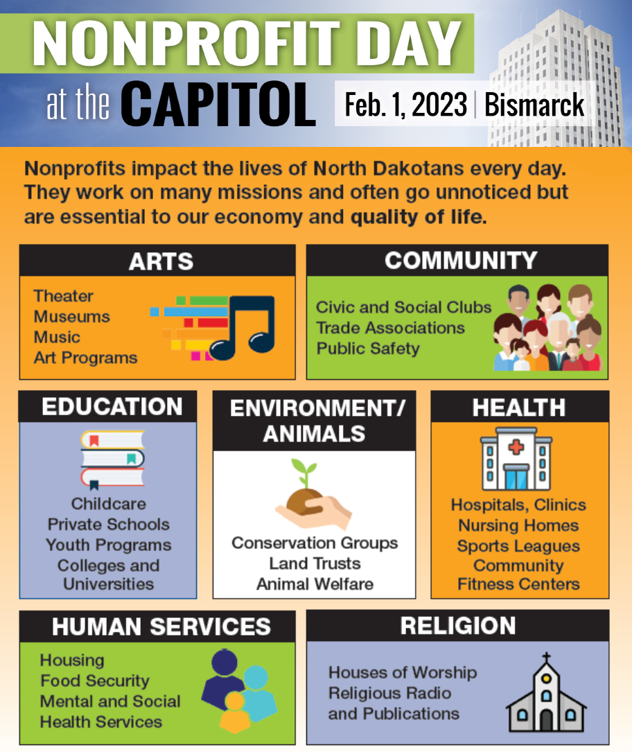

Nonprofits impact the lives of North Dakotans in a variety of ways. Where are some areas nonprofits have impacted your life? Join us in advocating for nonprofits at Nonprofit Day at the Capitol on Feb. 1. #NDNonprofitDay23

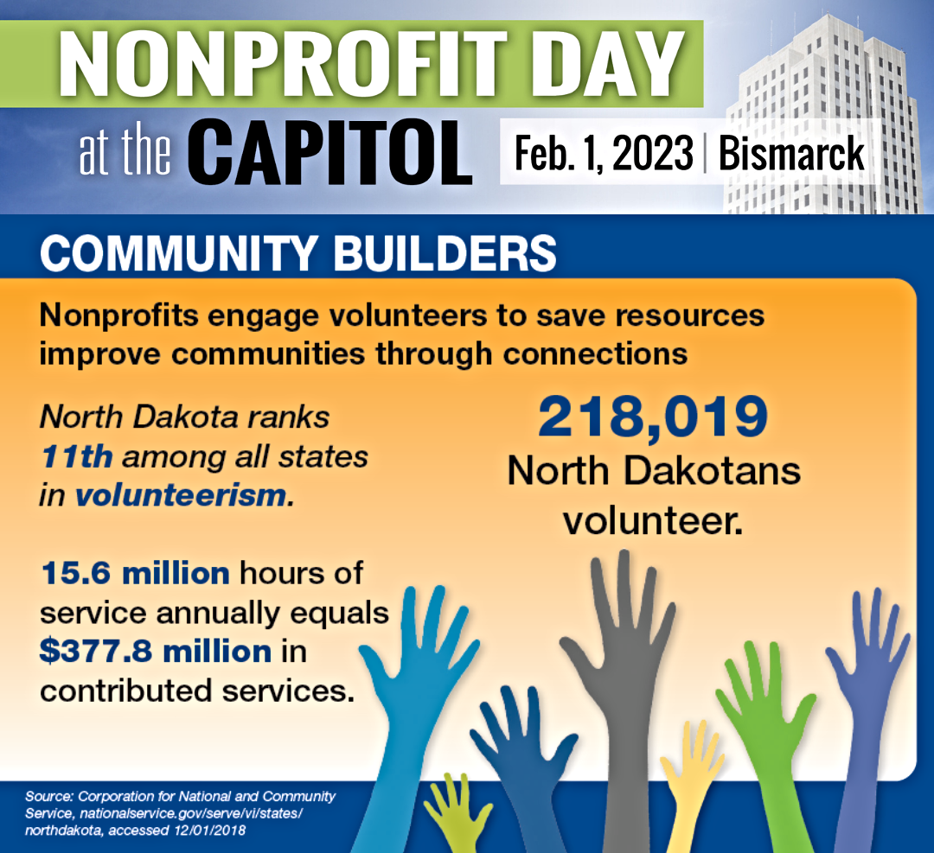

Did you know that North Dakota ranks 11th among all states in volunteerism? Nonprofits drive community engagement to improve the state through volunteerism. Join us in advocating for nonprofits at Nonprofit Day at the Capitol on Feb. 1. #NDNonprofitDay23

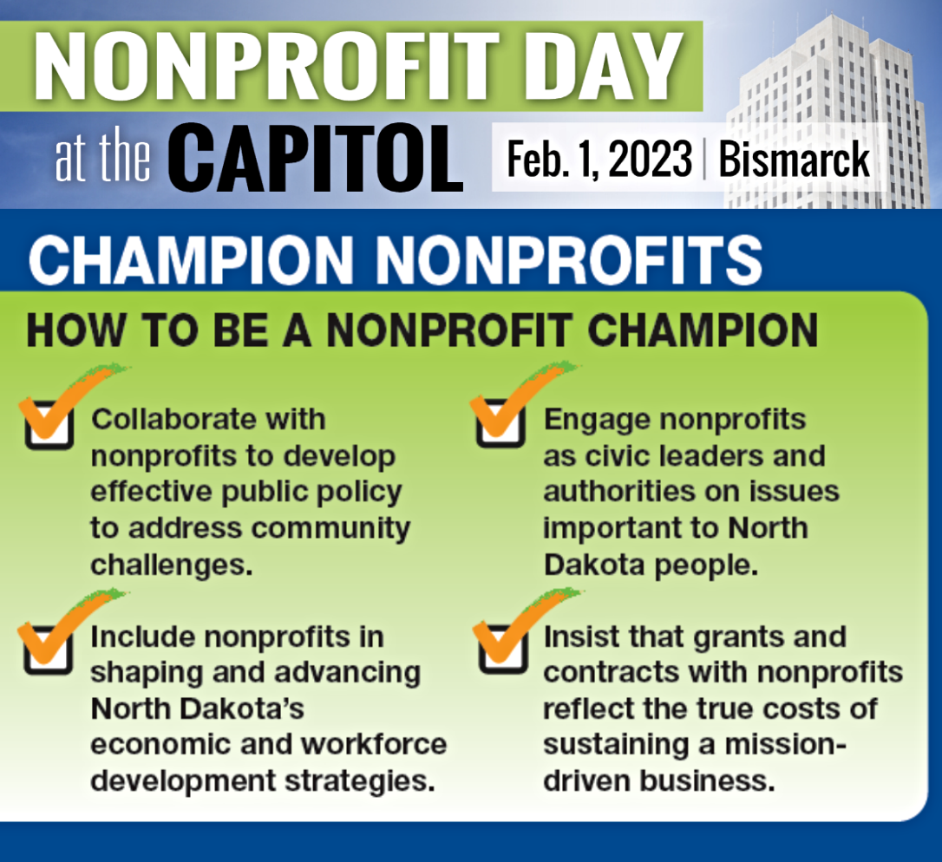

Are you passionate about nonprofits in North Dakota? Here’s a quick checklist of ways to be a nonprofit champion this year. Join us in advocating for nonprofits at Nonprofit Day at the Capitol on Feb. 1. #NDNonprofitDay23